Thomas Alan Broaddus obituary
February 27, 1956 – September 15, 2020

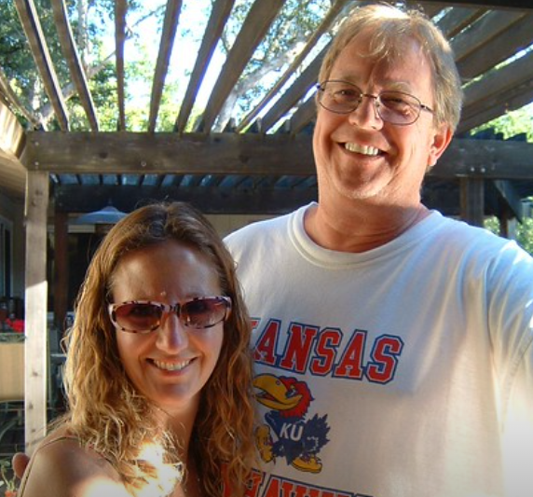

Thomas Alan Broaddus, of Danville, California, passed away on September 15th, 2020.
Tom was born in Kansas City, graduating from Southwest High School, after Bryant elementary and Bingham middle school. Two years at K.U. then transferred to K-State to earn a degree in Ag. During college Tom worked for his uncle in Oklahoma two summers, wheat harvest of course, and once discing until midnight and then walking back two miles from the ‘west place’ under the stars. He participated in the local the softball games and made himself a part of the community. The next summer he hired onto a wheat harvest crew in Kansas and Nebraska. He visited California with his elder brother, Jim, with a drive-away during the winter of his last year in college, saw the orchards in CA, and fait accompli.
Tom was always very active and kept his mother busy. A call from the Missouri Highway Patrol when picked up hitch-hiking in the Ozarks with a friend, ages 17, did not surprise her. Tom had many interests which when young included snakes (once losing a five-foot black snake in the station wagon), a series of waltzing mice and responsible for an adopted rooster in the basement, a ‘gift’ of Mr. Smith, a farmer up the road from the ‘farm’. We returned it after it began to crow early mornings. At the home on 67th Street, our next door neighbor, Andy Schmidtlein, built a four by two-foot box for Tom, to house a black snake gathered at ‘the farm.’ The viewing wall was a large piece of plexiglass. Neighborhood children gathered into Tom’s bedroom room to witness the feeding of the snake, the capture and squeeze of the mouse purchased from ‘The Menagerie’ on Troost. That was the snake that was lost in the Oldsmobile.
Tom was a great cook; made a great Bearnaise sauce, and then came the BBQ competitions, and at home brisket in a smoker, checking in the middle of the night. He loved Swan’s on Polk Street, as well as reading Herb Caen back in the day, and having dinner with Dick and Jan at Washington Square. He knew SF well and could real off the street names south and north of California Street.
Tom loved rock’n’roll. With friends he enjoyed many concerts, to include the Stones in ’72 in K.C., Dylan with friends in St. Louis in ’72. He especially liked Mott the Hoople where Queen opened the show at the Pla-Mor Ballroom in 1971. He took his younger brother to several Stones shows as well as Pink Floyd in 1995 at the Oakland Coliseum.
Tom was skilled with a camera, starting early with a Canon F1, and imparted and shared with it with his younger brother. His younger brother Phil was fortunate to use a dark room in the house at Linden Lane, that Tom talked the parents into building. The equipment was all there. Later, Tom and his younger brother shared a strong love of birding. Tom successfully lured Western Tanagers and Hooded Orioles to his back yard at his home in Danville.
Tom was a very active and vocal supporter of his children’s basketball and baseball teams and instilled in them an outstanding sense of humor and common sense. Also, he loved Death Valley and Joshua Tree and left the family 256 potted cacti, many of which he would patiently observe in the middle of the night, when flowering.
Tom lit up every room he walked into. Everyone who knew him strenuously agrees to that. Friends from his youth, in Kansas City, confirm. A natural for sales, orthopedic for 30 years, he earned the respect of the doctors and brightened the day of everyone in and outside of the OR.
Tom leaves his wife Beverly, sons Andrew and Jackson, step-father Wallace Richard Keene, and his younger brother Philip. He was pre-deceased by his mother, Janet Card Broaddus Keene, father James Anderson Broaddus, elder brother James Gregory Broaddus, of Boulder, Colorado, and step-brother Stuart Winfield Keene.

